Angular

Angular is basically designed for single page application(SPA), it means we should have a navigation from the same page to another components of Angular Application

## Data Bindings:-

1. The “data binding” is relation between “Component” and the “template”
2. When the value of “Component” is changed, the “template” will be changed automatically. When the value of “template” is changed, the “component” will be changed automatically
   1. Interpolation Binding
   2. Property Binding
   3. Event Binding
   4. Two-way Binding
3. Interpolation Binding
   1. Syntax : {{property}}
   2. It displays the value of the property in the template
   3. When the value of the property is changed, the same will automatically updated on the template.

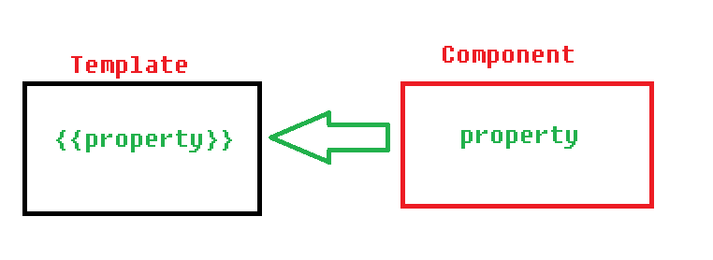

1. Property Binding
   1. Syntax: <tag [attribute]=”property”></tag>
   2. “Property Binding” is used to send the data from component to template and the assign same into an attribute of the tag
   3. When the value of the property is changed, the value will be automatically updated the template.

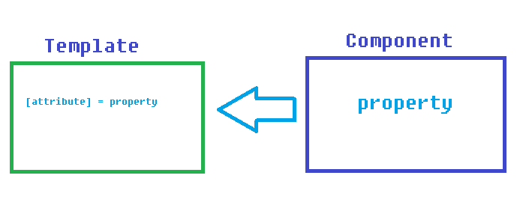

1. Event Binding\
   1. Syntax: <tag (event) = “method()”></tag>
   2. It is used to pass the event information from the template to component

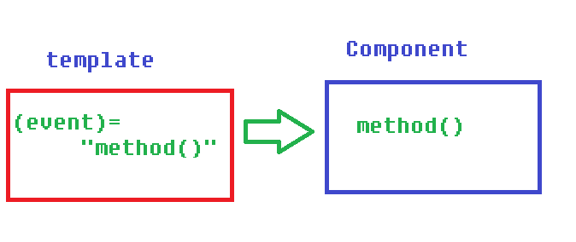

1. Two way Binding
   1. Syntax: <tag [(ngModel)] = “property”></tag>
   2. Two way Binding is combination of Property Binding” and “Event Binding”
   3. When you change the value of the property, the same will be automatically updated in the “html element”
   4. When you change the value of “html element”, the same will be automatically updated in the “property”
   5. The “ngModel” is pre-defined directive which is used to create the two way binding
   6. Two way bindings is application only for <input> and <select>
   7. “FormsModule” must be imported in order to use two-way binding

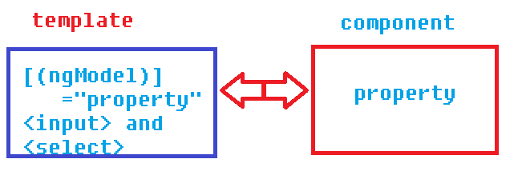

Example on Interpolatiion

